Hotel Room Booking
System

No | Name
1. | System Overview
2. | Model Descriptions
4. | Authentication & Authorizatio
5. | Booking Lifecycle
6. | File Upload Architecture
7. | Key Features Summary
8. | Configuration & Deployment
9. | Next Steps

System Overview
The Hotel Booking System is a full-stack web application that enables hotel room reservations with administrative oversight. The system implements a three-tier architecture with a backend API server, MongoDB database, and support for frontend client applications.

Primary Use Cases
Actor | Capabilities
Guest User | Browse available rooms, create booking requests, view booking history, pay for approved bookings
Administrator | Manage room inventory, approve/reject booking requests, view system statistics, cancel bookings
System | Track room availability, enforce booking workflow, store uploaded images, maintain audit trails

Technology Stack
The system is built with the following core technologies:
Layer | Technology | Purpose
Runtime | Node.js | JavaScript runtime environment
Framework | Express.js | HTTP API server
Database | MongoDB | Document-based data persistence
ODM | Mongoose | MongoDB object modeling
Authentication | jsonwebtoken (JWT) | Stateless authentication tokens
Password Security | bcryptjs | Password hashing
File Upload | multer | Multipart form data handling
Frontend Dev | Vite | Development server on port 5173

High-Level Architecture
System Component Diagram

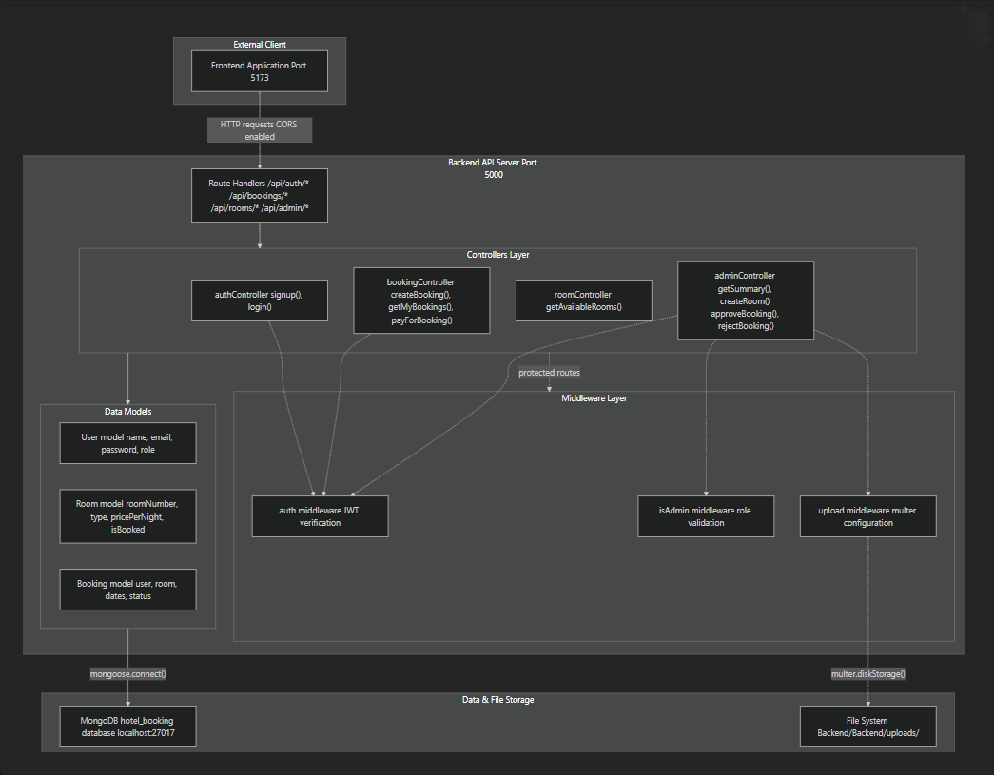

This diagram maps the complete system architecture with actual code symbols. All API requests flow through route handlers to controller functions, which may be protected by middleware before executing business logic through model classes.

Core Data Models
The system defines three primary Mongoose schemas that represent the domain model:
Model Relationships
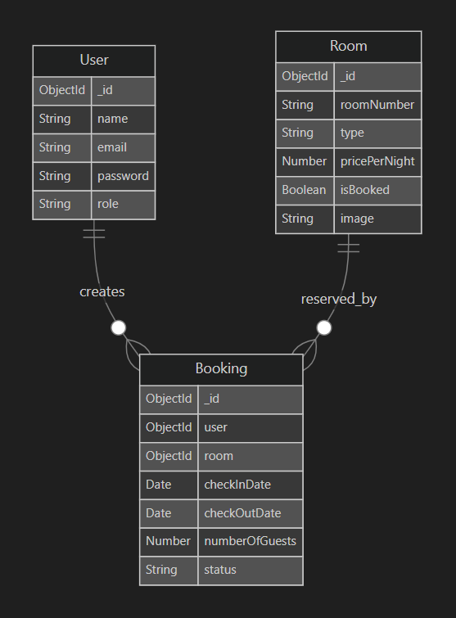
Model Descriptions

Model | File Reference | Purpose
User | Backend/models/User.js | Stores user accounts with hashed passwords and role-based access (user or admin)
Room | Backend/models/Room.js | Represents hotel rooms with pricing, type, and availability tracking via isBooked flag
Booking | Backend/models/Booking.js | Associates users with rooms for specific date ranges, tracking lifecycle via status field

Authentication & Authorization Flow

Purpose and Scope :

This document describes the security infrastructure of the Hotel Booking System, covering user authentication and role-based authorization mechanisms. The system implements a JWT-based stateless authentication model with bcrypt password hashing and two-tier authorization (authenticated users and administrators).

Security Architecture Overview :

The authentication and authorization system consists of three primary components:

Component | File | Purpose
Authentication Controller | Backend/controllers/authController.js | Handles user signup and login, issues JWT tokens
Authentication Middleware | Backend/middleware/auth.js:5-19 | Verifies JWT tokens on protected routes
Authorization Middleware | Backend/middleware/auth.js:22-27 | Enforces role-based access control for admin routes

The system implements a two-layer security model:
- Authentication Layer: Verifies user identity via JWT tokens
- Authorization Layer: Enforces role-based permissions (user vs. admin)

Authentication Flow :
User Registration (Signup)
The signup function in ‘ Backend/controllers/authController.js’ handles new user registration with the following validation and security steps:
Validation Steps
- Required Field Validation
  - Validates presence of name, email, password, and confirmPassword
  - Returns 400 Bad Request if any field is missing
- Password Confirmation ‘Backend/controllers/authController.js’
  - Ensures password matches confirmPassword
  - Prevents accidental typos during registration
- Email Uniqueness ‘Backend/controllers/authController.js’
  - Queries User.findOne({ email }) to check for existing accounts
  - Returns 400 with message "Email already registered" if duplicate found
Password Hashing
- Uses bcryptjs with 10 salt rounds (configurable cost factor)
- Generates unique salt per password for security
- Produces one-way hash that cannot be reversed

Authentication Process
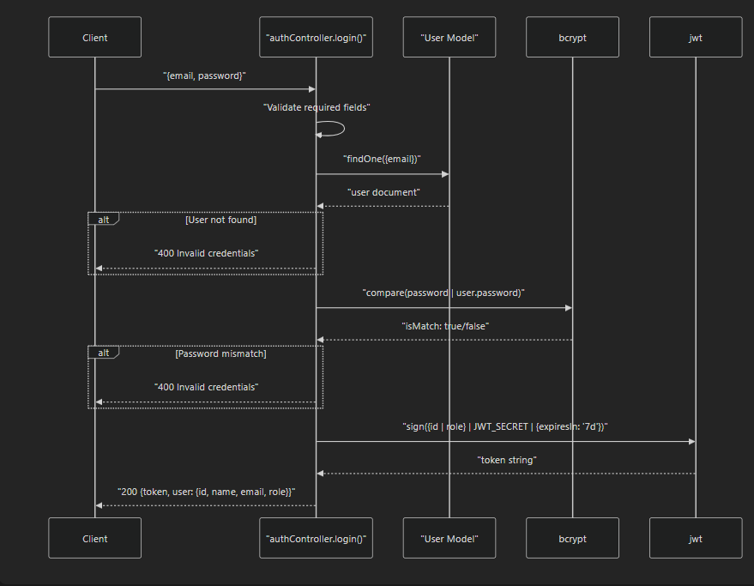

Middleware Protection Chain
- Protected routes apply middleware in sequence:
Request → auth middleware → (optional) isAdmin middleware → controller function
↓ ↓
Verify JWT Check role === "admin"
↓
Attach req.user
Authentication Sequence

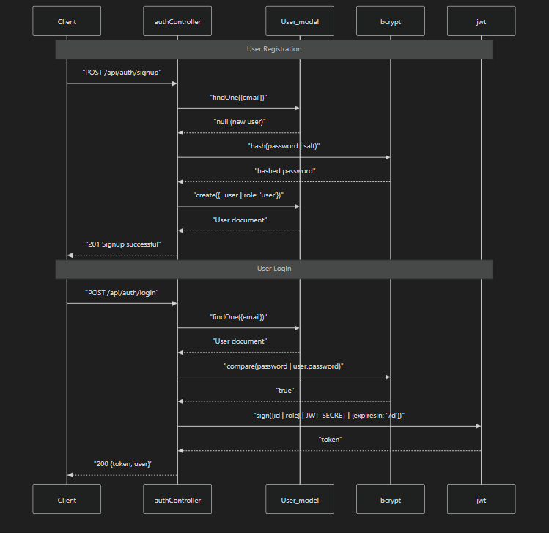
Booking Lifecycle
Booking State Transitions
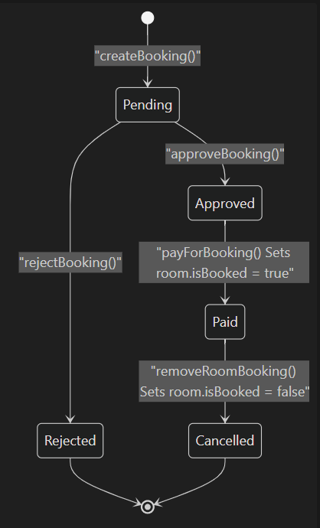
State Validation Rules

Current Status | Allowed Transitions | Validation Logic
Pending | → Approved, → Rejected | Admin-only via approveBooking() or rejectBooking()
Approved | → Paid | User must own booking, verified in payForBooking() at ‘Backend/controllers/bookingController.js’
Paid | → Cancelled | Admin-only via removeRoomBooking()
Rejected | None | Terminal state
Cancelled | None | Terminal state

The payForBooking() function performs an atomic operation that both updates booking status and locks the room
File Upload Architecture

The system supports image uploads for room creation using multer middleware:
Upload Flow
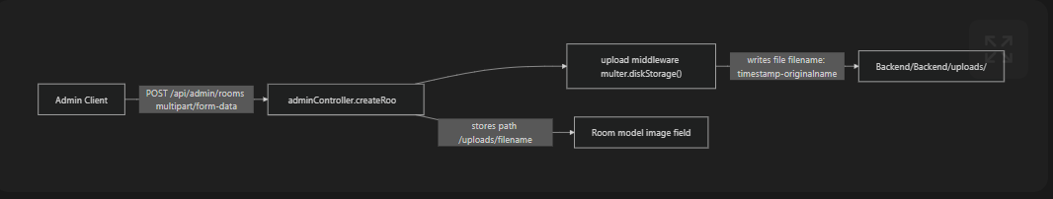

File Storage Implementation :
The upload middleware generates unique filenames by combining Unix timestamps with original filenames, preventing collisions during concurrent uploads. The file path is stored in the Room.image field, while the binary data resides in the uploads directory.

Key Features Summary
User Features
- Room Browsing: Query available rooms via getAvailableRooms() filtering on isBooked === false
- Booking Creation: Submit reservation requests with date validation
- Booking History: View all personal bookings via getMyBookings()
- Payment Processing: Complete approved bookings, triggering room lock

Administrative Features
- Room Management: Create rooms with image uploads, view complete inventory
- Booking Oversight: Approve/reject pending requests, cancel paid bookings
- System Monitoring: View dashboard statistics via getSummary()
- Availability Control: Manually release rooms via removeRoomBooking()

Security Features
- Password Security: bcrypt hashing with salt rounds
- Stateless Authentication: JWT tokens with 7-day expiration
- Role-Based Access: Dual middleware chain (auth + isAdmin)
- Ownership Validation: Payment restricted to booking owner
Configuration & Deployment
Environment Variables
The system requires four environment variables defined in ‘Backend/.env’:

Variable | Default Value | Purpose
PORT | 5000 | Backend API server port
MONGO_URI | mongodb://localhost:27017/hotel_booking | MongoDB connection string
JWT_SECRET | supersecretrecidencyhotel | JWT signing key
FRONTEND_URL | http://localhost:5173 | CORS allowed origin
Database Connection : The connectDB() function in ‘Backend/config/db.js’ establishes MongoDB connectivity
Request Flow Example : The following diagram illustrates a complete request flow for creating and paying for a booking:
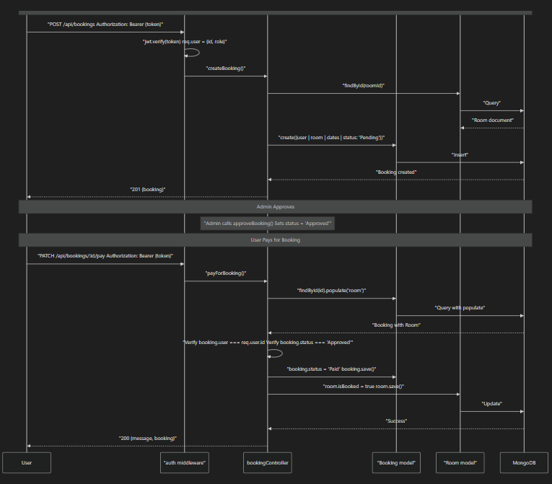

This sequence demonstrates the multi-stage booking process with administrative approval, ownership verification, and atomic room locking.
Next Steps
To understand specific subsystems in detail, refer to the following documentation pages:
- Getting Started: Environment setup, database initialization, admin user creation
- System Architecture: Detailed three-tier architecture, component interactions
- Data Models: Complete schema definitions, validation rules, relationships
- Authentication & Authorization: JWT implementation, middleware details, security model
- API Endpoints Reference: Complete API documentation with request/response examples
- Booking Workflow: Detailed booking lifecycle, state machine, business rules
- Administrative Functions: Admin capabilities, room management, booking oversight

